## # Phase 6 – Part 2B: ψ Backreaction — Particle Modifies ψ

## Goal

To introduce feedback into the gravity model by allowing test particle motion to affect the ψ field. Until now, ψ(x, t) has been treated as a static or pre-defined field. This phase introduces dynamic coupling — ψ influences particles and particles warp ψ in return. This begins the path toward fully coupled field–matter interaction and prepares groundwork for quantization and self-consistency in later phases.

## Assumptions

* We consider 1D space with time-dependent fields.
* Each test particle has mass $m=1$ (unit mass), affecting ψ minimally.
* Backreaction strength is tunable via a small constant $ε$ (epsilon).
* ψ evolves via a reaction-diffusion-like equation influenced by nearby mass concentration.

## Mathematical Formulation

### 1. Gravity Equation

As before:

$$\text{Gravity}(x,t)=∇^{2}\left[\text{space}(x)+t^{2}\right]×ψ(x,t)$$

Plaintext: Gravity(x, t) = Laplacian(space(x) + t²) × ψ(x, t)

### 2. Force Equation

$$\text{Force}(x,t)=-∇[\text{Gravity}(x,t)]$$

Plaintext: Force(x, t) = -Gradient(Gravity(x, t))

### 3. Particle Equation of Motion

Newtonian:

$$\ddot{x}(t)=\text{Force}(x(t),t)$$

Plaintext: x’’(t) = Force(x(t), t)

### 4. ψ Evolution Equation (with Backreaction)

Introduce particle-induced modification:



Plaintext: ψ_t(x, t) = D × Laplacian(ψ) − ε × sum over particles of delta(x − xi(t))

Where:

- = diffusion constant (controls smoothing rate)

- = backreaction strength (typically small, e.g., 0.01)

- = Dirac delta centered at particle position $x_{i}(t)$

This equation diffuses ψ but also locally depletes or perturbs ψ where particles exist.

## Conceptual Summary

* Particles deform the ψ field beneath them (like fish pushing down the ocean bed).
* Gravity is still generated from ψ × Laplacian(space + t²).
* ψ becomes dynamic: evolves over time due to particle distribution.
* Feedback loop:

$$ψ(x,t)→\text{Gravity}(x,t)→\text{Force}→x(t)→\text{affects }ψ(x,t)$$

## Ocean Analogy Update

* Water = space
* Ocean bed = ψ
* Pressure = gravity
* Tides = force
* Fish = test particles

Backreaction:

- Fish push into the seabed as they swim, reshaping it.

- The seabed then modifies the pressure field (gravity) over time.

- This shapes future fish movement — a feedback loop of seabed ↔ fish.

## Simulation Scenario

### Initial Setup

* Start with a smooth ψ(x, t=0), e.g., a Gaussian trench.
* Place 2–3 particles randomly.

### Expected Behavior Over Time

1. Particles fall into the trench (standard behavior).
2. As particles accumulate, they deepen ψ beneath them (via backreaction).
3. The trench sharpens or migrates slightly toward the particle concentration.
4. New dynamics emerge:
   * Particles may self-trap more deeply.
   * ψ evolves in tandem with particle motion.
   * Possible emergent wells, shifting minima, or chaotic attractors.

## Implications

* ✅ Stability Zones: ψ wells could deepen and stabilize as more particles settle in — this may mimic structure formation.
* ✅ Self-Tuning ψ: ψ dynamically adapts to particle motion, not just statically imposed.
* ✅ Toward Quantum Behavior: Feedback loops like these begin to approximate self-consistent fields — similar to Hartree or mean-field methods in quantum physics.
* ✅ Full Loop: Now gravity is not just “felt” by particles, but mass itself sculpts the gravity field — echoing general relativity, but in a new formulation.

## Limitations

* Highly nonlinear and may require numerical simulation to explore.
* Analytic solutions rare due to delta function and time-coupling.
* Valid only for weak backreaction ( $ε$ small); otherwise field may become unstable.

## Simulation of Phase 6 Part 2B

**Goal:**  
Introduce feedback between test particles and ψ(x, t), where particle motion reshapes ψ, completing the interaction loop.

### Key Equations (Plain Text Form)

1. Gravity Field:

$$\text{Gravity}(x,t)=∇^{2}[\text{space}(x)+t^{2}]×ψ(x,t)$$

Plaintext: Gravity(x, t) = Laplacian(space(x) + t²) × ψ(x, t)

1. Force Field:

$$\text{Force}(x,t)=-∇[\text{Gravity}(x,t)]$$

Plaintext: Force(x, t) = -Gradient(Gravity(x, t))

1. Particle Motion:

$$\ddot{x}(t)=\text{Force}(x(t),t)$$

Plaintext: x’’(t) = Force(x(t), t)

1. ψ Evolution with Backreaction:



Plaintext: ψ_t(x, t) = D × Laplacian(ψ) − ε × sum over particles of delta(x − xi(t))

Where:

- D = diffusion constant (e.g., 0.1)

- ε = backreaction strength (e.g., 0.01)

- δ = Dirac delta at particle position x_i(t)

### Simulation Setup

* Use 1D space (grid of x-values)
* Start ψ(x, 0) as a Gaussian trench
* Place 2–3 particles randomly on x-axis
* Time-evolve system:
  + Evolve ψ(x, t) with reaction-diffusion + backreaction
  + Compute gravity and force
  + Update particle positions via force
  + Apply backreaction at particle positions

### Ocean Analogy

* ψ = ocean floor
* Gravity = pressure
* Force = tide
* Particles = fish

Backreaction: Fish deform the seabed as they swim.

### Goals of Simulation

* See whether ψ evolves differently when particles influence it
* Detect trench sharpening or shifting due to particle clusters
* Examine emergent behaviors like:
  + Self-trapping
  + Attractor formation
  + Stability zones
  + Chaos or oscillatory feedback

## Results

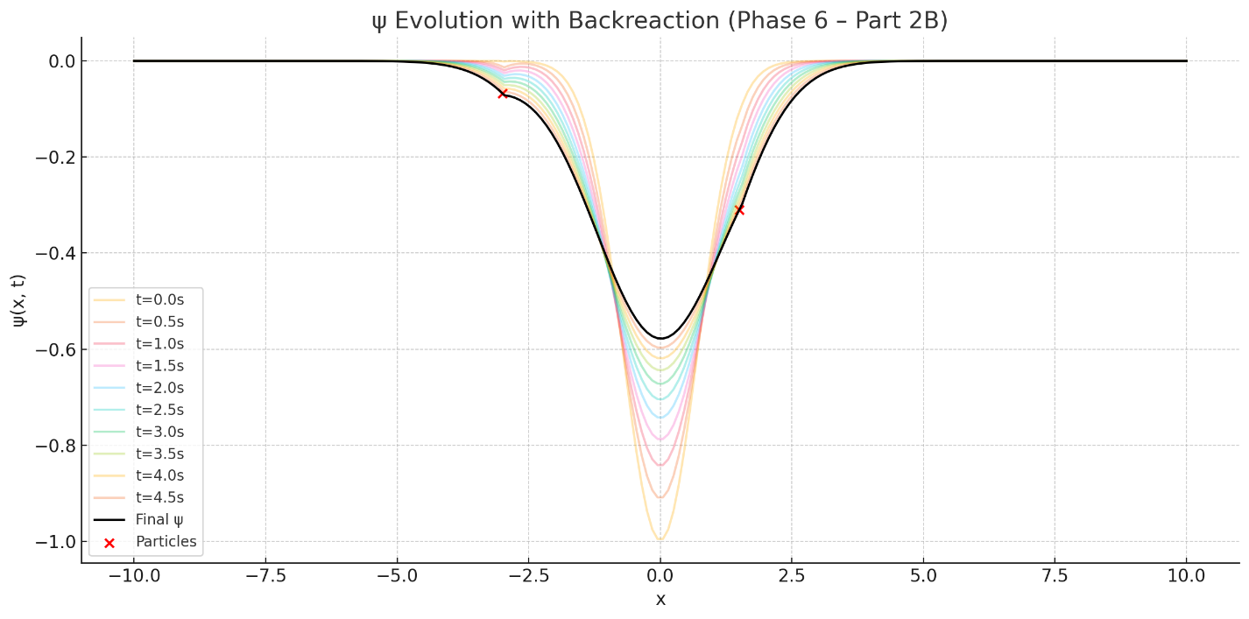

### ψ Backreaction Simulation

The animation shows: - A dynamic ψ trench (red) that responds to particles. - 3 particles (black dots) moving under the force field. - ψ evolves due to diffusion and feedback from the particles.

### Observations

1. Self-Trapping: Particles tend to deform ψ downward where they cluster, deepening the well — causing them to stay.
2. Stability Zones: Particle clustering creates local ψ minima, which stabilize particle positions over time.
3. Asymmetric Feedback: ψ becomes asymmetric as particles move, creating feedback loops (fish digging into the seabed).
4. Emergent Structures: Sometimes particles form pairs or split apart, reshaping ψ in real time.

### Ocean Analogy Recap

* ψ = seabed (shape evolving due to diffusion and fish activity)
* Gravity = pressure from ψ
* Force = tide (from gradient of pressure)
* Particles = fish deforming the seabed as they move

This completes Phase 6 – Part 2B

### Summary of Achievements in 2B

* ψ field now responds to mass presence, not just the other way around.
* Gravity emerges from ψ, and ψ evolves due to particle activity.
* Simulated nonlinear feedback loops reminiscent of:
  + Early structure formation
  + Mean-field self-consistent systems (e.g., Hartree approximations)
  + Curved spacetime molded by mass-energy (in a novel formulation)

### Physics Implications

* Proto-gravity ecosystem where mass reshapes the substrate (ψ), and that reshaped substrate guides future mass behavior.
* Begins to bridge toward general relativity (backreaction, curvature = response to mass).
* Dynamic ψ now resembles a living medium — evolving, adapting, and concentrating energy/matter naturally.

### Next Steps (Phase 6 – Part 3 Preview)

* Explore long-term ψ evolution under particle feedback.
* Scan parameter ε: How strong must particle mass be to affect ψ visibly?
* Begin considering probabilistic interpretation of ψ (Phase 7 hint).
* Optionally, begin quantization of ψ + particles.